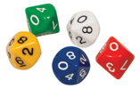 Dice Multiplication 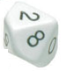
Materials: two dice; two different coloured counters; game board
- Taking turns, Player 1 and Player 2: Roll the two dice. Multiply the numbers. Cover the product with a counter.
- Once a square has been covered, it cannot be used again.
- When the gameboard us full, the person who has the most coloured counters is the winner.

0 | 63 | 32 | 30 | 45 | 54
24 | 16 | 27 | 36 | 18 | 12
49 | 40 | 35 | 28 | 36 | 21
18 | 25 | 24 | 20 | 16 | 15
14 | 12 | 10 | 9 | 8 | 7
6 | 5 | 4 | 3 | 2 | 1
72 | 56 | 42 | 48 | 64 | 81

